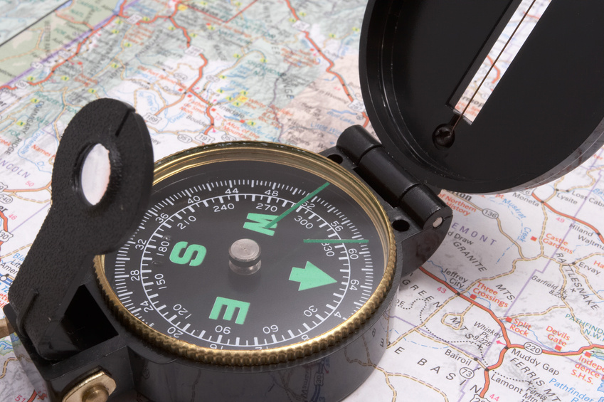

Using the map bellow, try to find places in the world using latitude and longitude coordinates. First, read the coordinates (remember, latitude goes across, longitude goes up). Next, find the location where the lines of latitude and longitude intersect. Finally, write the name of the ocean or continent that the coordinates led to in the space labeled “location.” If you get completely lost, highlight the boxes in the “hint” column for help finding your way. Good Luck!

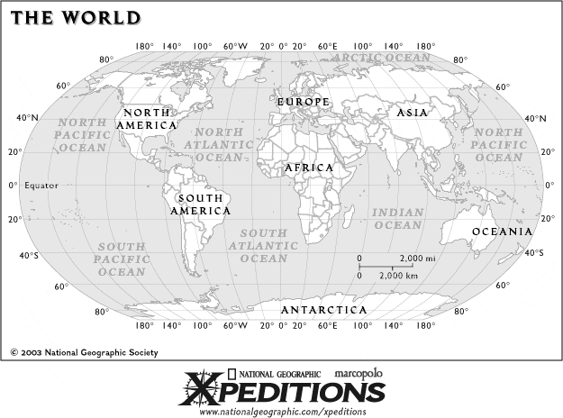

LATITUDE / LONGITUDE COORDINATES | LOCATION | HINT
20 N, 20 E |  | Africa
40 N, 100 W |  | North America
80 S, 60 E |  | Antarctica
0, 20 E |  | Africa
60 N, 20 E |  | Europe
0, 100 E |  | Indian Ocean
20 N, 140 E |  | North Pacific Ocean
0, 0 |  | South Atlantic Ocean
40 N, 140 W |  | North Pacific Ocean
40 S, 60 W |  | South America

