Name ________________________ Math Lesson Multiplication LESSON 1
Directions: Decipher the Code message listed below to uncover the sentences. Place the answers directly below the Code.
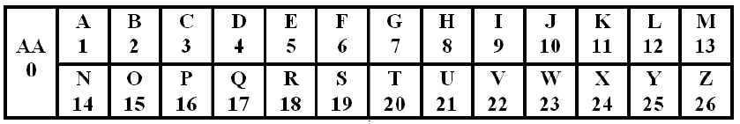
- E x J = EO __5___ x __10___ = 50 Example
- G x H = EF _______ x _______ + _____
- D x E = T _______ x _______ + _____
- D x F = X _______ x _______ + _____
- M x B = Z _______ x _______ + _____
- E x E = Y _______ x _______ + _____
- P x B = CB _______ x _______ + _____
- H x H = FD _______ x _______ + _____
- Y x B = EO _______ x _______ + _____
- K x B = V _______ x _______ + _____

