Spreadsheet Assignment Excel Marvin’s
Saved as assign8 excel
You will create a spreadsheet and a graph in this assignment. If you follow the directions closely and look at the output in Figure 7A, you should not have any problems.
- Go to Excel spreadsheet. Click Cell A1, you will type in and highlight the words “Marvin’s Music & Movie Mirage”. Change to a font size of 16 and BOLD and stretch to column F. Then click the merge and center tool located in the middle of the tool bar. Look below for location.
- Type in the fields listed in column A. You may have to adjust the size of the column’s width. To do that just bring the mouse up to the top of column A and place it on the cell line between A and B. This will cause an arrow to go both directions, hold down the button and you may now slide the column width of the cell over to make it large enough. You may adjust the headings to the left by highlighting the headings and then click on the correct menu option.
Merge and center tool.
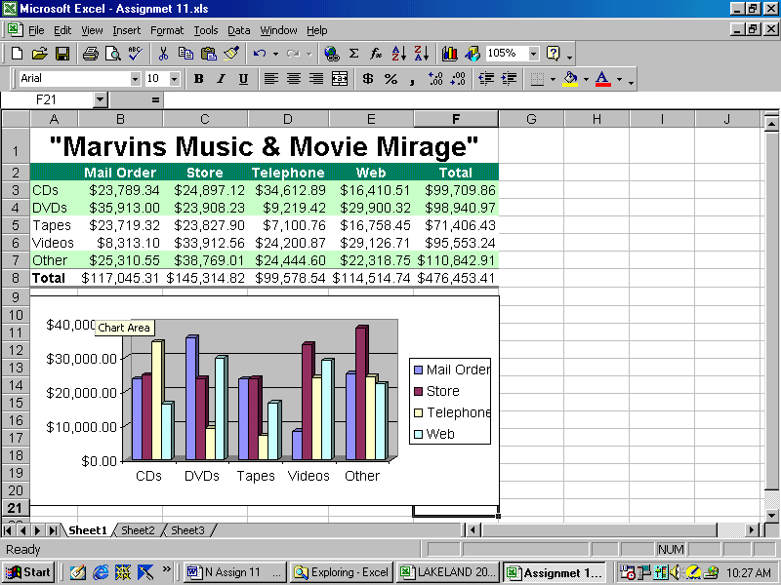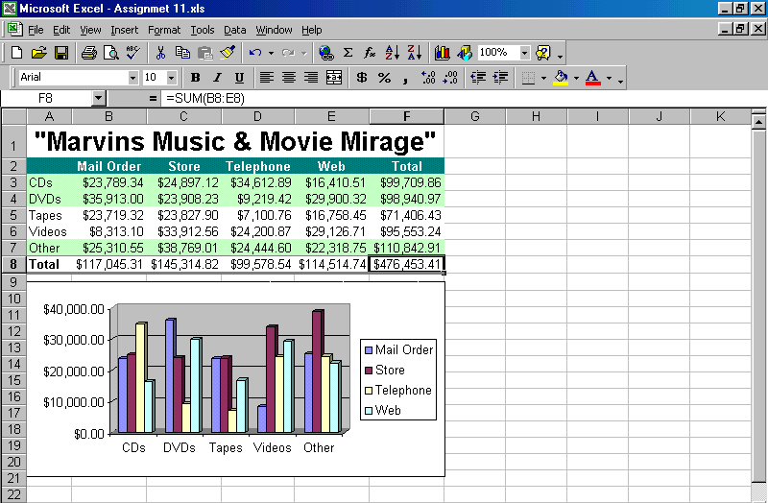
Chart wizard tool

Please type in the numbers above without the commas. DO NOT TYPE IN the numbers in column F or in all of row 8.
- If a field shows all ####### that simply means the column or cell is not big enough to handle the number in the cell. Just do the same as you did above to enlarge the cell.
- After typing in the numbers you will learn how to use the sum function you only need to place the cursor in Cell B8 and click on the sum function ∑. Hit the enter key. This will allow for the total of the column to be placed in Cell B8.
- CREATING SUM EQUATIONS FOR A COLUMN. You may now use the computer's special functions to do what is called a fill across. If you look close you will find a cross hair located in the lower right corner of Cell B8. Place the cursor there and hold down the left mouse button and drag the cursor to the range of Cell E8. You will notice that the equations for each cell will adjust automatically relative to each column.
- CREATING SUM EQUATIONS FOR A ROW
You will perform the same functions as above in steps 5-6 only apply them to a row. This will be done in column F Cell F3.
- USING AUTOFORMAT TO FORMAT THE BODY OF THE SPREADSHEET
Place the cursor in cell A2, Highlight the spreadsheet to Cell F8 and then go to Format / AutoFormat and choose List 1 (Column 2 ) as the design. The range will be A2 – F8. This will give you a fancier spreadsheet.

Adding a 3-D Column Chart to the Worksheet

- You are creating an embedded chart. It is called that because it is drawn on the same worksheet as the data.
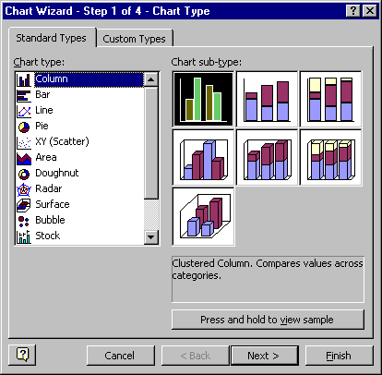
- Select Cells ( A2 through E7). With this highlighted you may now click the Chart Wizard button shown in figure 7A. This will create a pull down chart menu. Please choose the 3-D Column indicated by the arrow. Click the finish button and this will allow for the chart to be created. Place the cursor in the upper area of the chart. The right button and pull down chart appears. FORMAT CHART AREA - choose a color or fill effect that you want.
- PRINTING OUT AN EMBEDDED CHART & SS Use the mouse to grab the chart and move it to a location that will not be touching the cells containing numbers. You will now need to click an area of the spreadsheet that is not a chart. This will allow you to printout an embedded chart with the spreadsheet. Go to preview to view this assignment prior to printing out a hardcopy.
- HEADERS AND FOOTERS
- When you have finished the chart as you would like it, you need to create headers. To do this you must do the following:
- 1. Go to View and headers and footers.
- 2. Custom header
- Place YOUR NAME and ASSIGNMENT No. #? on the left section and use the center section for the date and time. You will find the commands for that located at the top middle.
- Please printout and turn in per
Example (figure 7A)
- Make sure you save this assignment as you will copy and paste this in the next assignment.
